OBI411 cB Medical Demo programming procedure

1. mount the OBI board on the USB programmer module, antenna (the blue ‘fractus’ component) away from the USB connector.
2. Install connectBlue Toolbox software; see the installation notes and link to download in the document: <http://support.connectblue.com/display/PRODTOOLS/cB-2138+Serial+Port+Adapter+Toolbox>
3. Plug programmer module (with OBI411 board) into Windows computer. If your computer complains that it can’t find a device driver, you’ll need to install the FTDI driver, see: <http://support.connectblue.com/display/Dashboard/ACC-34>
4. Start the Serial Adapter Toolbox program (connectBlue/Serial Port Adapter Toolbox/Serial Port Adapter Toolbox)
5. The “Select Product” screen should pop up. Select the “Bluetooth IO” radio box and [OK].
6. The main screen of the toolbox will come up. [Connect] (lower left).
7. If you have configured another device, these parameters may be set as they were the last time.
8. If this is a new device (not already programmed), you should [default]. Either way, [OK].
9. [AT Mode]. If all is OK at this point, the main screen should look like this:  
     
   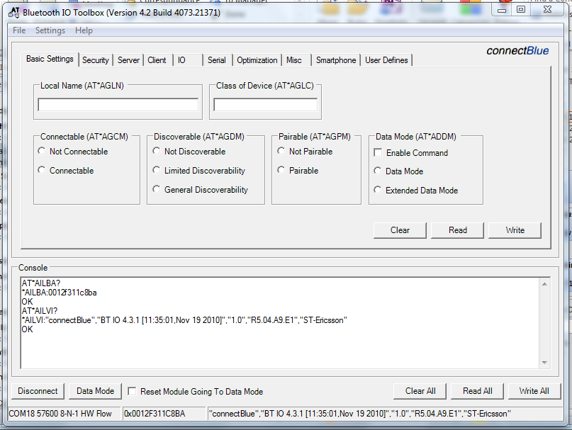
10. Choose File, Download Configuration from the main menu (top left). Navigate to the file included with these instructions (a .txt file) and [Open].
11. The software will load the file and execute the commands in the Console window at the lower center of the screen.
12. Select (check) the “Reset Module Going To Data Mode” (bottom left, next to [Data Mode]).
13. Click on [Data Mode], then click on [Disconnect]
14. Now [Connect] and configure the serial parameters as shown below (9600, N, 8, 1, none):  
      
    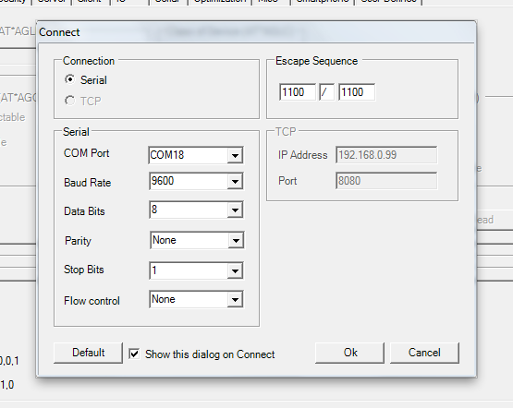
15. [OK]
16. [AT Mode], [Read All] (lower right)
17. If all has been successful, your screen should look like the following (yes, the errors in the Console window are normal):  
      
    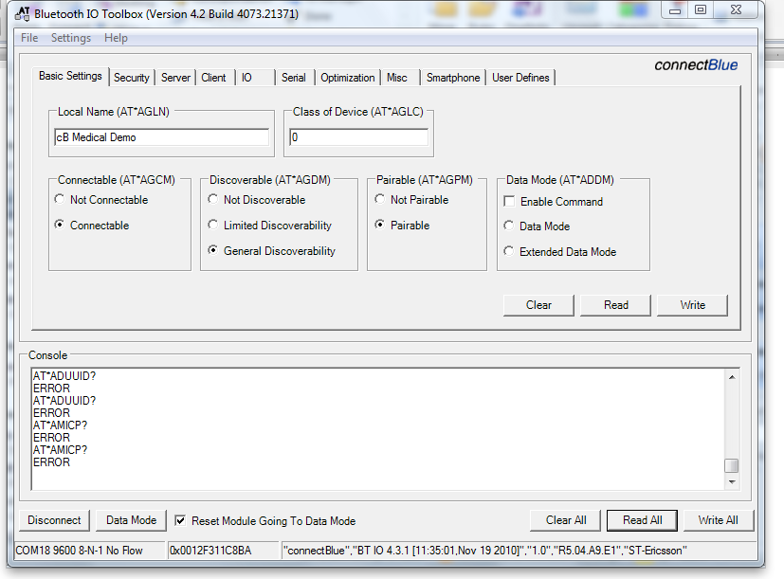
18. [Data Mode], [Disconnect] and exit the program.
19. You can now remove the USB module from the computer
20. Remove the module from the programming board and fix it onto the ECG board. Note that the antenna on the OBI board should be on the side furthest away from the 9-pin DIN serial connector.